Media Permissions Report

OPTION 1: Global Version (draws on Permission Requested, Spanish Permission Requested, Permission Response, and Spanish Permission Response elements in media docs)
Checkboxes (one required, but can select more than one):
___ Permission Requested (English) (if selected, only include media docs with Permission Requested=Yes)
___ Permission Requested (Spanish) (if selected, only include media docs with Spanish Permission Requested=Yes)
OR
___ Show All Denied Permission Requests (English and Spanish) (if selected, only include docs with Permission Denied in either the Permission Response or Spanish Permission response element in media docs)
OR
OPTION 2: Specific Version (draws on Approved Use element within the Permissions block in Media docs)
Choose Doc Type - summary or glossary or all (to see all media docs that have been approved for use in summaries and/or glossary)
OR
Select Summary Language and Summary Type (to limit results to a certain set of summaries that have been approved to contain images)
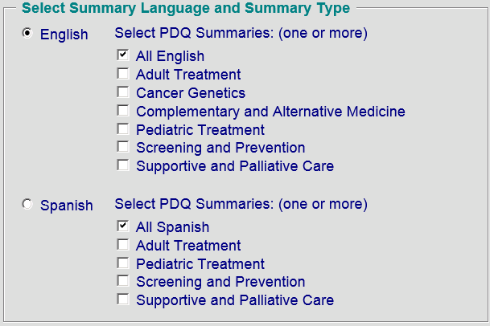
OR
Enter the CDR ID of a certain summary or glossary term (to see all images that have been approved for use in a specific summary or glossary term)

AND (to be used with either option 1 or option 2 of the report)
Optional date range (date permission requested)
Optional date range (date permission expires)

Ideally, we would like to have the option of HTML or Excel output (let’s discuss LOE)
Sample Report Output:
Media Permissions Report – Option 1
In this example, the following option was selected:
_X_ Permission Requested (English)
Please sort by Media doc title.
Media DocTitle | Permission Request Date | Permission Response (Response Date) | Expiration | Spanish Permission Requested (Permission Response) | Approved Use | Comment
Late Effects - Peak growth hormone according to hypothalamic mean dose and time after start or irradiation (CDR 87589) |  | Permission Granted (2012-03-28) |  | Yes (Permission Granted) | Late Effects of Treatment for Childhood Cancer (CDR12345)  Glossary term (CDR87598)
Late Effects – Probability of developing an underactive thyroid (CDR 57892) |  | Permission Granted (2012-02-21) |  | No | Late Effects of Treatment for Childhood Cancer (CDR12345) | Cannot translate, not on permissions agreement
Late Effects – sample document (CDR 657892) | 2014-02-19 | Permission Granted (2014-02-19) | 2015-02-19 | Yes (Permission Granted) | Late Effects of Treatment for Childhood Cancer (CDR12345) | Permission expires in 1 year.
Pedigree symbols – sample document (CDR 348792) | 2014-02-05 | Permission Denied (2014-02-07) |  | Yes (Permission Denied)

Media Permissions Report – Option 1
In this example, the following option was selected:
_X_ Show All Denied Permission Requests (English and Spanish)
Please sort by Media doc title.
Media DocTitle | Permission Request Date | Permission Response (Response Date) | Spanish Permission Requested (Permission Response) | Comment
Late Effects - Peak growth hormone according to hypothalamic mean dose and time after start or irradiation (CDR ID) |  | Permission Denied (2012-03-28) | Yes (Permission Denied)
Late Effects - Peak growth hormone according to hypothalamic mean dose and time after start or irradiation (CDR ID) |  | Permission Denied (2012-03-28) | No
Late Effects – Probability of developing an underactive thyroid (CDR ID) |  | Permission Granted (2012-02-21) | Yes (Permission Denied)

Media Permissions Report – Option 2
In this example, the following option was selected:
_X_ English Pediatric Treatment summaries
Please sort by Approved Use and create a separate row for each approved use
Approved Use | Media DocTitle | Permission Request Date | Permission Granted Date | Expiration | Spanish Permission Requested (Permission Response) | Comment
Glossary term (CDR87598) | Late Effects - Peak growth hormone according to hypothalamic mean dose and time after start or irradiation (CDR ID) |  | 2012-03-28 |  | Yes (Permission Granted)
Late Effects of Treatment for Childhood Cancer (CDR12345) | Late Effects - Peak growth hormone according to hypothalamic mean dose and time after start or irradiation (CDR ID) |  | 2012-03-28 |  | Yes (Permission Granted)
Late Effects of Treatment for Childhood Cancer (CDR12345) | Late Effects – Probability of developing an underactive thyroid (CDR ID) |  | 2012-02-21 |  | No | Cannot translate, not on permissions agreement
Late Effects of Treatment for Childhood Cancer (CDR12345) | Late Effects – sample document (CDR ID) |  | 2014-02-19 | 2015-02-19 | Yes (Permission Granted) | Permission expires in 1 year.
Late Effects of Treatment for Childhood Cancer (CDR12345) | Late Effects - Cumulative incidence curves of nonsurgical premature menopause (CDR ID) |  | 2011-11-16 |  | No | Cannot translate, not on permissions agreement

